## Congratulations Modal Functionality

Modal pops up when all of the cards have been matched:

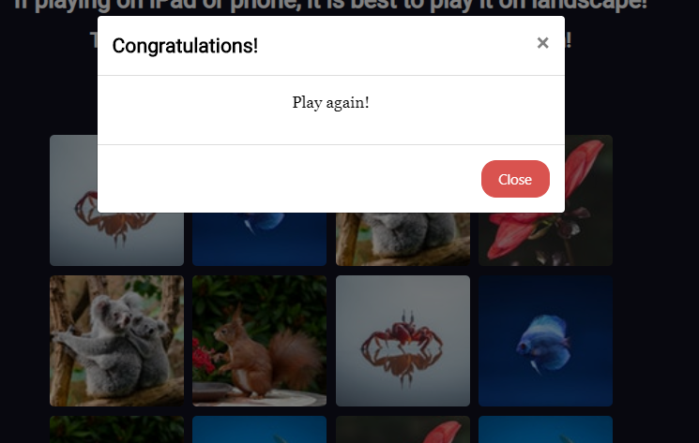

## New Game Button Functionality

When clicked on, the game will turn the cards back over and reshuffle the cards:

* I press the ‘Close’ button.



* I click the ‘New Game’ button which will start a new game and reshuffle the cards:

